SQL PROBLEM STATEMENT

* Create tables given in image (Save create query)

1. **CREATE** **TABLE** COMPANY_MAST

* CODE :-

**CREATE** **TABLE** COMPANY_MAST

(

COM_ID **INT** (40),

COM_NAME **VARCHAR**(50)

);

**INSERT** **INTO** COMPANY_MAST (COM_ID, COM_NAME)

**VALUES**('11', 'SAMSUNG');

**INSERT** **INTO** COMPANY_MAST (COM_ID, COM_NAME)

**VALUES**('12', 'IBALL');

**INSERT** **INTO** COMPANY_MAST (COM_ID, COM_NAME)

**VALUES**('13', 'EPSION');

**INSERT** **INTO** COMPANY_MAST (COM_ID, COM_NAME)

**VALUES**('14', 'ZEBRONICS');

**INSERT** **INTO** COMPANY_MAST (COM_ID, COM_NAME)

**VALUES**('15', 'ASUS');

**INSERT** **INTO** COMPANY_MAST (COM_ID, COM_NAME)

**VALUES**('16', 'FRONTECH');

* OUTPUT:-

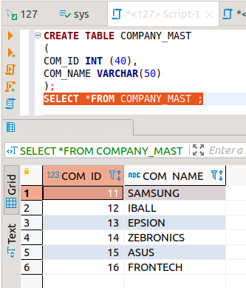

1. **CREATE** **TABLE** ITEM_MAST

* CODE:-

**CREATE** **TABLE** ITEM_MAST

(

PRO_ID **INT** (40),

PRO_NAME **VARCHAR**(50),

PRO_PRICE **INT** (50),

PRO_COM **INT** (50)

);

**INSERT** **INTO** ITEM_MAST (PRO_ID, PRO_NAME, PRO_PRICE, PRO_COM)

**VALUES**('101', 'MOTHER BOARD', 3200, 15);

**INSERT** **INTO** ITEM_MAST (PRO_ID, PRO_NAME, PRO_PRICE, PRO_COM)

**VALUES**('102', 'KEY BOARD', 450, 16);

**INSERT** **INTO** ITEM_MAST (PRO_ID, PRO_NAME, PRO_PRICE, PRO_COM)

**VALUES**('103', 'ZIP DRIVE', 250, 14);

**INSERT** **INTO** ITEM_MAST (PRO_ID, PRO_NAME, PRO_PRICE, PRO_COM)

**VALUES**('104', 'SPEAKER', 5000, 16);

**INSERT** **INTO** ITEM_MAST (PRO_ID, PRO_NAME, PRO_PRICE, PRO_COM)

**VALUES**('105', 'MONITOR ', 900, 11);

**INSERT** **INTO** ITEM_MAST (PRO_ID, PRO_NAME, PRO_PRICE, PRO_COM)

**VALUES**('106', 'DVD DRIVE', 800, 12);

**INSERT** **INTO** ITEM_MAST (PRO_ID, PRO_NAME, PRO_PRICE, PRO_COM)

**VALUES**('107', 'CD DRIVE', 862, 112);

**INSERT** **INTO** ITEM_MAST (PRO_ID, PRO_NAME, PRO_PRICE, PRO_COM)

**VALUES**('108', 'PRINTER', 250, 13);

**INSERT** **INTO** ITEM_MAST (PRO_ID, PRO_NAME, PRO_PRICE, PRO_COM)

**VALUES**('109', 'REFILL CARTRIDGE', 350, 13);

* OUTPUT :-

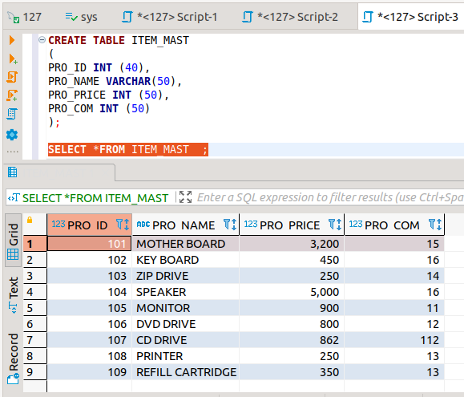

1. List average price of items of each company

* CODE :-

**SELECT** **AVG**(pro_price), pro_com

**FROM** ITEM_MAST

**GROUP** **BY** pro_com;

* OUTPUT:-

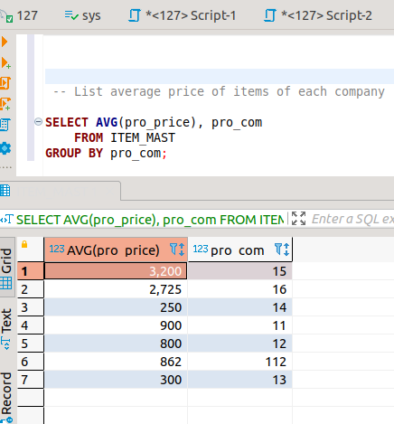

1. List item where company name starts with “E”

* CODE ;-

**SELECT** *

**FROM** COMPANY_MAST

**WHERE** COM_NAME **LIKE** 'E%';

* OUTPUT:-

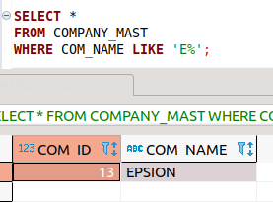

1. Get Detail with columns
2. Prod_ID
3. Prod_Name
4. Prod_Price
5. Company_name

